How to install Artanize App

Interface

1st action : Open app

- logo entry

- signup :
with google or facebook or with e-mail

- main page :
brain with many circuits, bubules, infos, examples of tools…

popup :
-quick tour (e.g.
in three steps.
1- add bubble with hold touch
2- tap to open b<
3- swipe to move in the bubble (e.g.3D Brain (brainfacts.org)) , add uploads, discussion bubbles and texts notes.

End

once done play with artanize

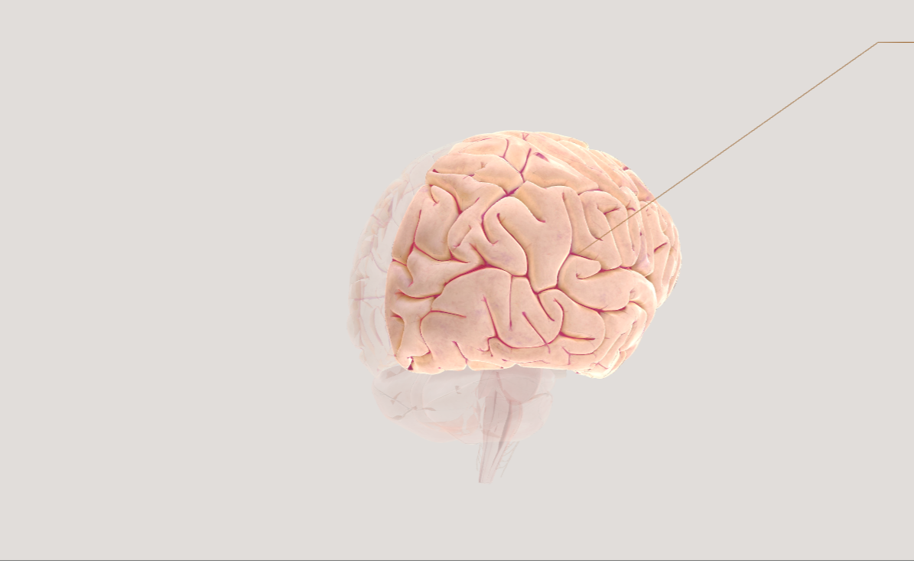
image (BRAIN)
image (bubble)


image (uploads)


image (uploads)


image (uploads)



image


image
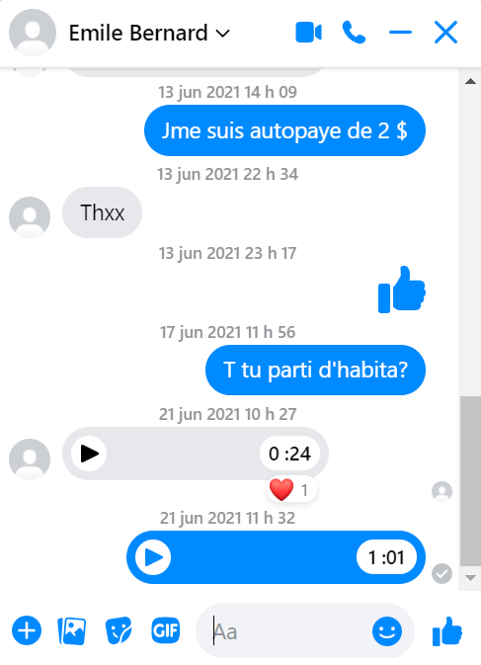

image

image

image

